Report from the Cumberland Valley Firemen’s Association
Convention and Presidents Council Meeting

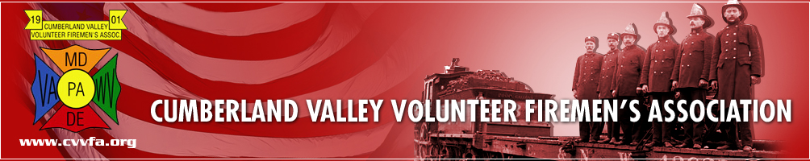

The CVVFA convention was held on Thursday and Friday, August 3 & 4, 2017 at the McConnellsburg Fire Station in McConnellsburg, PA.. Those attending from the DVFA were President Ted Walius, 1st Vice President Rich Perillo, 2nd Vice President Bill Betts, Secretary Elmer Steele and Executive Manager Warren Jones.

We arrived at 6:00 PM on Wednesday and settled in for the night at the Sleep Inn in Clear Spring, MD.

Thursday morning, we traveled 40 minutes to the McConnellsburg Fire House for the business meeting, general convention business and keynote speaker Todd Leiss from the State of Pennsylvania Turnpike Traffic Incident Management office.

There was a picnic on Thursday night at the McConnellsburg American Legion picnic grounds. There was lots of food, fun and fellowship for everyone that attended.

We arrived at the fire station at 8:30 AM on Friday for the President’s Council meeting. This meeting involves reports, issues and concerns from the 7 States that are members of the Council, as well as reports from our National and Federal leaders. As you will see in this report, numerous issues and concerns are the same from State to State.

Our own Steve Austin was the MC for the meeting and kept things moving along on a steady pace.

CVVFA: CVVFA President Bill Keller welcomed the members of the President’s Council to the
McConnellsburg Fire Station for their convention meeting.

Pennsylvania: President Rich Grove brought greetings from the Commonwealth of Pennsylvania. They are working on grants for the coming year. They are also working on legislation dealing with cancer presumption and legalizing fireworks in the State. Don Konkle discussed other legislative issues.
Pennsylvania Convention will be September 21-23, 2017 at Penn Hills, PA

Maryland: MSFA 1st Vice President Rich Blair brought greetings from the State of Maryland. He then gave reports and comments for the State of Maryland, MFRIS, MIEMSS, MEMA, MSP and Shock Trauma. A written report is available.

National Fire Heritage: Wayne Powell discussed the Heritage Center and what they are doing to preserve fire history. The museum is located in the Frederick County Fire-Rescue Museum in Emmitsburg, MD
West Virginia: John Ashcraft reported that Workman’s comp has dropped fire companies in West Virginia. They had to purchase private insurance to cover their members. There was supposed to be money put in at the legislative level to help with the cost of this private insurance, but at the last minute it was taken out.
West Virginia Convention will be August 23-25, 2017 in Moundsville, WV

New Jersey: Harry Carter brought greetings from New Jersey. He reported on a slowdown in the legislative process. He talked about their various legislative bills, budgets and some issues within the State.
New Jersey Convention is the same time as Delaware. September 14-17, 2017 in Wildwood, NJ

Delaware: Delaware Volunteer Firefighter’s Association President Ted Walius brought greetings from Delaware. Ted introduced the folks in attendance from Delaware and then turned the program over to Warren for a power point presentation. Warren discussed numerous issues that are of concern to Delaware; Grant in Aid, Joint Finance funding, R&R and our involvement with the Delaware State Fair.
DVFA Conference will be held on September 11-16, 2017 at the Dover Downs Hotel & Casino in Dover, DE.

New York: Not in attendance

Virginia: Not in attendance. Their convention is in session this week.

CFSI: Sean Carroll, Director of Government Affairs for the Congressional Fire Services Institute brought greetings from Washington. Sean discussed AFG and SAFER grants, FY 2018 funding, Firefighter Occupational Cancer, Fire Sprinkler Incentive Act, Recruitment & Retention and several other issues that CFSI is dealing with in Washington.

NVFC: Dave Finger gave a report for the National Volunteer Fire Council. NVFC is working on funding, Recruitment and Retention and cancer presumption issues. Printed report available.

IAFC: Report was given for the International Association of Fire Chief’s.

CVVFA: CVVFA President Bill Keller gave information on the remaining events for the Convention; banquet tonight, prayer breakfast tomorrow and parade tomorrow.

During the breaks, there was ample time to talk and socialize with the members from the different
States and Agencies in attendance. There was printed material and reports available with lots of
valuable information.

Respectfully submitted,
Elmer B. Steele
Elmer B. Steele, DVFA Secretary

