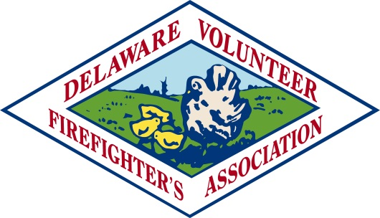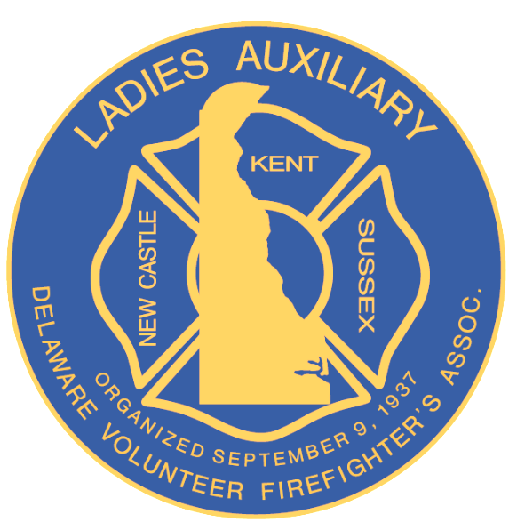
Delaware Volunteer Firefighter’s Association
Delaware Volunteer Firefighter’s Association Ladies Auxiliary

Conference 2020
Dover Downs Hotel and Casino
September 14, 2020 through September 18, 2020

Due to the coronavirus pandemic and the Governor’s State of Emergency, the 2020 DVFA/LADVFA Annual Conference was cancelled to protect the health and well-being of our members.

All contracts with Dover Downs were cancelled and our refund was returned to us, in full.

A survey monkey poll was sent out to the member companies, Past Presidents, Current Officers and Directors to get feedback on how to proceed with the election of Officers for 2021 or to leave the current Officers in place for another year. (2-year term) See results below. Officers will remain in place for another year.

RESULTS OF SURVEY MONKEY VOTE
RESOLUTION TO LEAVE OFFICERS IN THEIR CURRENT POSITION
UNTIL 2021 CONFERENCE

New Castle County 13 yes 14 no Total of 27 votes cast

Kent County 22 yes 2 no Total of 24 votes cast

Sussex County 22 yes 4 no Total of 26 votes cast

Past Presidents 13 yes 5 no Total of 18 votes cast

Officers, Directors, 5 yes 2 no Total of 7 votes cast

75 yes 27 no Total eligible votes cast 102

Respectfully submitted,

Elmer B. Steele
Elmer B. Steele, Secretary
Delaware Vol. Firefighter’s Assoc.

Attest to; Warren Jones Norman “Jay” Jones, Jr
Executive Manager DVFA President

