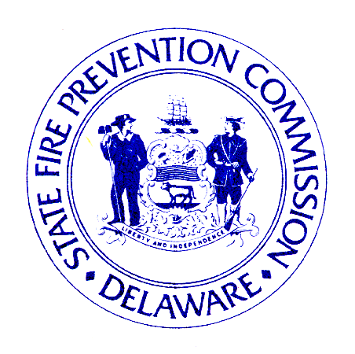

STATE OF DELAWARE
STATE FIRE PREVENTION COMMISSION
DELAWARE FIRE SERVICE CENTER
(302) 739 – 3160 1463 CHESTNUT GROVE ROAD
FAX (302) 739 – 4436 DOVER, DELAWARE 19904

PLEASE RETURN COMPLETED FORM TO:

STATE FIRE PREVENTION COMMISSION

1463 CHESTNUT GROVE ROAD
DOVER, DE 19904

FAX or Email to: Sherry.Lambertson@state.de.us

2015 Fire Company Information Updates

Company Name |  | Station Number

Mailing Address

911 Street Address | City Zip

Phone Number |  | Fax Number

E-Mail Address

Web Page

Contact Information

Priority Contact

Mailing Address

Home: |  | Work: |  | Cell:

E-mail Address

President

Mailing Address

Home: |  | Work: |  | Cell:

E-mail Address

Vice President

Mailing Address

Home: |  | Work: |  | Cell:

E-mail Address

Treasuer

Mailing Address

Home: |  | Work: |  | Cell:

E-mail Address

Secretary

Mailing Address

Home: |  | Work: |  | Cell:

E-mail Address

Fire Chief

Mailing Address

Home: |  | Work: |  | Cell:

E-mail Address

Deputy Chief

Mailing Address

Home: |  | Work: |  | Cell:

E-mail Address

EMS Officer

Mailing Address

Home: |  | Work: |  | Cell:

E-mail Address

Training Officer

Mailing Address

Home: |  | Work: |  | Cell:

E-mail Address

Fire Recorder

Mailing Address

Home: |  | Work: |  | Cell:

E-mail Address

Recruitment

Mailing Address

Home: |  | Work: |  | Cell:

E-mail Address

Ladies Auxiliary President

Mailing Address

Home: |  | Work: |  | Cell:

E-mail Address

**This form will be disseminated to the Office of State Fire Marshal, Delaware State Fire School and Delaware Volunteer Firefighter’s Association. This list has been created in an effort to keep your company contacts updated and informed**

** Please return this form by January 1, and no later than February 1, **

