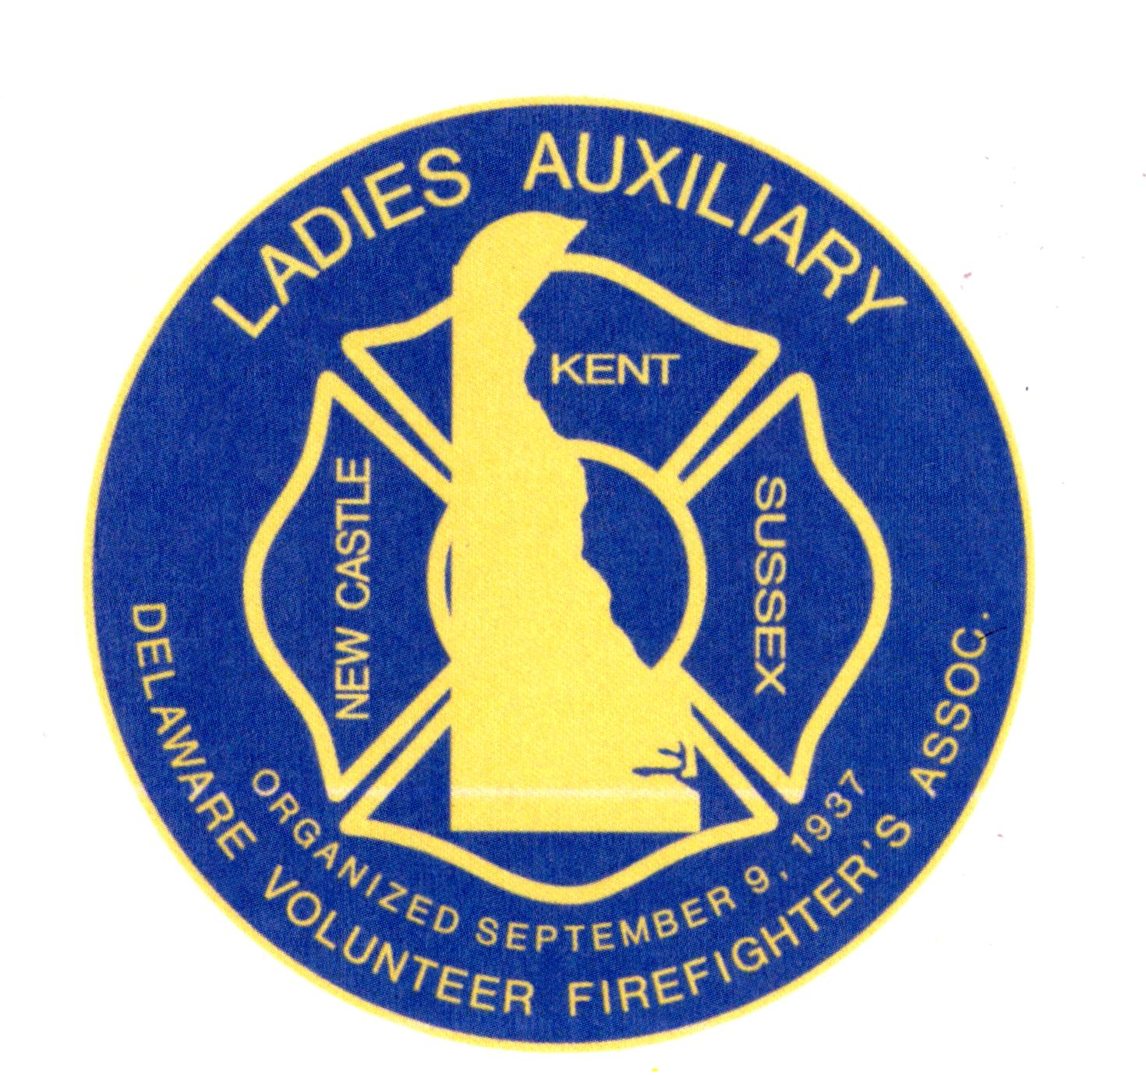LADIES AUXILIARY DELAWARE VOLUNTEER FIREFIGHTER’S ASSOCIATION
CONFERENCE CHECKLIST

KENT COUNTY ACTION REQUIRED AND DUE DATES FOR CONFERENCE

State Dues ($75) Must be paid to County Treasurer, Judi Conover, by June 30^{th.}. Make check payable to Kent County Volunteer Firefighters’ Association Auxiliary.

State Conference Assessment Must be paid to County Treasurer, Judy Conover, by June 30^{th.}. Make check
($200) payable to Kent County Volunteer Firefighters’ Association Auxiliary.

LADVFA 50/50 Lottery ($50) Must be paid to County Treasurer, Judi Conover, by June 30th. Make check payable to Kent County Volunteer Firefighters’ Association Auxiliary.

Names of Delegates and Two copies are in your packet. Send ONE copy of this form to State
Alternates Secretary, Karen Barlow. Keep a copy for your files. If you need to make any changes, the Auxiliary President needs to send the change to the State Secretary on Auxiliary letterhead prior to the Thursday meeting at Conference. Form is due by July 15th.

Names of Deceased Members Two copies are in your packet. Send ONE copy to State Secretary,
and Pictures Karen Barlow, and THE OTHER COPY to Sandy Robinson, Kent County President. Please send a clear photograph to Sandy and write the name and auxiliary of the deceased on the back. The picture will be used in the panorama at the Memorial Service on Friday, September 14th. Please mail forms and pictures by July 15th. Your County President is the only one who is to receive the pictures; your pictures will be returned to you.

Financial Report Two copies are in your packet. Send ONE copy to your County President, Sandy Robinson, by July 15th. Bring the other copy with you to Conference.

Hospitality Return registration form to Cindy Humphreys, 302-745-9747, by July 15th.

Luncheon Return registration form to Isabel Stevenson, (302) 245-5418, by July 15th.

Golf Tournament Return registration form and payment to PSP Barbara A. Rossiter. For questions, please call (302) 737-3245 or cell (302) 354-0645 by July 15th. If you have a sponsor for the golf tournament, please submit form at the same time.

Mutual Relief Return registration form to Virginia Tice, (302) 542-1972, by July 15th.

Hall of Recognition Please return submissions to your Kent County representative by July 15th.

50-Year Recognition Please return submissions your Kent County representative by July 15th.

Please make sure you have returned above items to the proper person by the deadline date of July 15th. This will help them meet their deadlines. Keep a copy of all correspondence for your files.
Thank you for your cooperation!
______________________________________________________________________________________________
Mrs. Sandy Robinson Mrs. Karen Barlow Ms. Judi Conover
Kent County President LADVFA Secretary Kent County Treasurer
101 W. South Street 800 East Avenue 256 N. Red Haven Lane
Smyrna, DE 19977 New Castle, DE 19720 Dover, DE 19901
sandyrob44@verizon.net kbarlow1218@gmail.com judijudijudi6@gmail.com
302-399-6005 302-658-0085 609-410-4283

