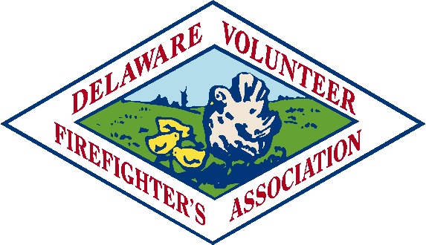
122 South Bradford Street, P. O. Box 1849, Dover, DE 19903
“Serving Delaware’s Volunteer Fire Companies Since 1921”
February 11, 2023

Dear President and Chief,
I am personally inviting you and your members to attend the National Fire and Emergency Services Symposium and 33rd Annual National Fire and Emergency Services Dinner. On May 22nd and 23rd, the Congressional Fire Services Institute will host the Symposium and Dinner in Washington, DC. The annual gathering is expected to draw over 1,500 fire and emergency services leaders from across the country. They will attend seminars, conduct meetings with their members of Congress and network with their colleagues. Your registration fee will cover the seminars on Monday and the dinner Tuesday evening.

You will not find another fire service event that explains how the federal government is addressing the challenges and concerns of our firefighters, emergency services personnel and the fire service industry. Opportunities abound to interact with members of Congress and federal agency officials to discuss both national issues and local concerns. The knowledge you will acquire will increase your understanding of federal programs and legislation, while emboldening you to take a stronger interest in advocating for fire and emergency services on Capitol Hill.
We are asking you again, to help Delaware attain the goal of being #1. The dinner is on Tuesday, May 23, 2023, at the Washington Hilton, at 7:00 p.m. The Delaware reception will begin prior to the dinner. You will receive that information when you check in at the Delaware desk. The registration form is attached. This year we have arranged special pricing just for the Delaware Fire Companies who attend. For full information on the Symposium go to the CFSI Website. Please take advantage of the special pricing and come join us in Washington to take part in this historic event.

Sincerely,

Ken Ryder

President

