Report from the Cumberland Valley Firemen’s Association
Spring Presidents Council Meeting

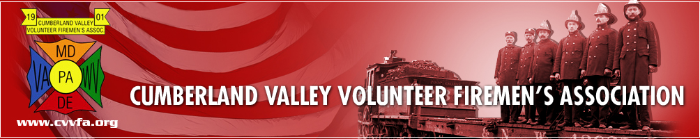

The CVVFA spring meeting of the Presidents Council was held on Saturday, April 2, 2016 at the Carroll County Training Center in Westminster, MD. Those attending from the DVFA were President Joe Zeroles, 1st Vice President Ted Walius, Secretary Elmer Steele and Executive Manager Warren Jones.

This meeting involves reports, issues and concerns from the 7 States that are members of the Council. As you will see in this report, a lot of the same issues and concerns are the same from State to State.

Our own Steve Austin was the MC for the meeting and kept things moving along on a steady pace.

CVVFA: CVVFA President Hoby Howell welcomed the members of the Presidents Council to the
Carroll County Training Center for their Spring meeting.

Maryland: MSFA 1st Vice President Michael Davis gave basic reports and comments for the State of Maryland, MFRIS, MIEMSS, MEMA and Shock Trauma and introduced other guests that were with the Maryland delegation. MSP gave information on the aviation division, Fire Marshal Geraci gave information from his office, Past President Bernie Smith gave an up-date of Maryland legislative issues.
MSFA 124th Convention will be held on June 18-24, 2016 in Ocean City, MD.

CFSI: Sean Carroll, Director of Government Affairs brought greetings from Washington. He discussed the CFSI dinner to be held on May 5, 2016. As a note, Congress will not be in session at that time, but staff members will be available. Sean discussed AFG and SAFER grants, FY 2017 funding, Firefighter Occupational Cancer, Fire Sprinkler Incentive Act, Recruitment & Retention and several other issues that CFSI is dealing with in Washington.

New York: Firemen’s Association of the State of New York (FASNY) President Robert McConville brought greetings from New York. They have developed a short video on cancer in the fire service, which was shown at this time. New York has done an economic impact study and a study on firefighter cancer and developed a 31 page report of their findings. This info is available on their web site. He introduced the other guests from New York and they gave additional comments on the study that was done.
FASNY 144th Convention will be held on August 10-13, 2016 in Albany, NY

Pennsylvania: State Fire Commissioner Tim Solobay brought greetings from Pennsylvania. Tim discussed the Junior Firefighter program in PA and how some federal laws are affecting that program regarding age limits. They are working on grants for the coming year. They are also working on legislation dealing with cancer presumption and legalizing fireworks in the State.

At this time, the group broke for lunch (11:55 to 12:35)

Delaware: Delaware Volunteer Firefighter’s Association President Joe Zeroles brought greetings from Delaware. Joe introduced the folks in attendance from Delaware. (total of 11) Joe discussed Recruitment & Retention issues, Fire Prevention issues within the school systems and then turned the program over to Warren for a power point presentation. Warren discussed numerous issues that are of concern to Delaware; Grant in Aid, Joint Finance meeting, R&R, legislation and the fire at legislative hall, which got the attention of our politicians, since Delaware is the only State Capital in the Nation to be protected by a volunteer fire service.
DVFA Conference will be held on September 12-17, 2016 at the Dover Downs Hotel & Casino in Dover, DE.

Virginia: Virginia State Firefighter’s Association President Jeff Flippo brought greetings from the Commonwealth of Virginia. Jeff discussed the funding process for Virginia’s fire service, the 2020 Vision for the State and legislation to legalize ALL types of fireworks. He stated that their Fire Marshal has just retired and they have started the process to fill that position.
VFSA 130th Convention will be August 17-20, 2016 at Hampton Roads Convention Center in Hampton.

West Virginia: There are 427 counties in West Virginia. A bill has been introduced to legalize fireworks in West Virginia also. They are having problems with workman’s comp and are trying to work out these issues.
West Virginia Convention will be August 11-13, 2016 at the Mardi Gras Casino & Resort in Cross Lanes, WV.

New Jersey: New Jersey has 21 counties and each County has their own training center. This is causing some problems, since training is not consistent from County to County. There is a push to make civilians Fire Police. This is being reviewed.
New Jersey Convention is the same time as Delaware. September 14-17, 2016 in Wildwood, NJ

CVVFA: CVVFA President Hoby Howell gave information on their Convention. It is being hosted by the Hartford and Cecil Counties and the various events will be at various locations. The Presidents Council meeting will be in Level, MD with the host hotel in Edgewood with a rate of $69.00 per night. The parade will be in Elkton.

During the breaks, there was ample time to talk and socialize with the members from the different
States and Agencies in attendance. There was printed material and reports available with lots of
valuable information.

Respectfully submitted,

Elmer B. Steele, DVFA Secretary

