Delaware Volunteer Firefighters Association and Ladies Auxiliaries
2021 Conference
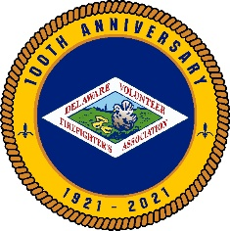
September 14 – 17, 2021

Annual Conference Booklet Advertising
The Delaware Volunteer Firefighter’s Association and the Ladies Auxiliary will be celebrating 100 years of serving the State of Delaware at our annual conference at the Chase Center in Wilmington. The Conference Committee is selling ads to be included in the Annual Conference Booklet. They are available to advertise a business; to recognize fire service members for years of service; to honor a member for holding an office or a special anniversary and so much more.

Ad size Price

Full Page $ 150.00

½ Page $ 75.00

¼ Page $ 50.00

1/8 Page $ 25.00

Patron Ad $ 5.00

All ads must be received by July 15, 2021. Please email the ad, in .pdf format, to DVFACONFERENCEBOOK@gmail.com. If you have any questions, please send an email to the address above. Please complete this form and return with payment to the address listed below. Please make the check payable to the Delaware Volunteer Firefighter’s Association.

Regina Headley-Marvel
22635 Zoar Road
Georgetown, DE 19947
Attn: Conference Book.

Name of Fire Company/Individual/Business___________________________________
Address and Phone number_____________________________________________
Email address______________________________________________________
Ad Size ____________ Amount _____________________

