President |  |  | First Vice President | Second Vice President | Secretary | Treasurer | Executive Manager
Theodore H. Walius |  |  | Richard T. Perillo | Willard R. Betts, Jr. | Elmer B. Steele | J. Allen Metheny, Sr. | Warren F. Jones
12303 DuPont Blvd |  |  | 509 Calhoun Road | P. O. Box 46 | 6259 Steffland Dr. | 2484 Arthursville Rd. | 22626 Southern Pines Dr.
Ellendale, DE 19941 |  |  | Wilmington, DE 19809 | Frederica, DE 19946 | Seaford, DE 19973 | Hartly, DE 19953 | Lewes, DE 19958
302-422-2328 H |  |  | 302-762-0569 H | 302-335-3437 H | 302-875-2164 H | 302-492-3755 H | 302-535-4566 C
302-430-2765 C |  |  | 302-382-2906 C | 302-535-7080 C | 302-542-8922 C | 302-270-4712 C | 302-947-4593 H

Past President, Director
Anthony Guzzo
505 Pershing Ct
Hockessin , DE 19707
302-239-7923 H
302-463-6168 C

Elected Directors

Clayton Yocum
Sussex County
302-393-9690 C
Daniel Carrier
New Castle County
302-635-4224 C

Kenneth Ryder
Kent County
302-245-1417 C

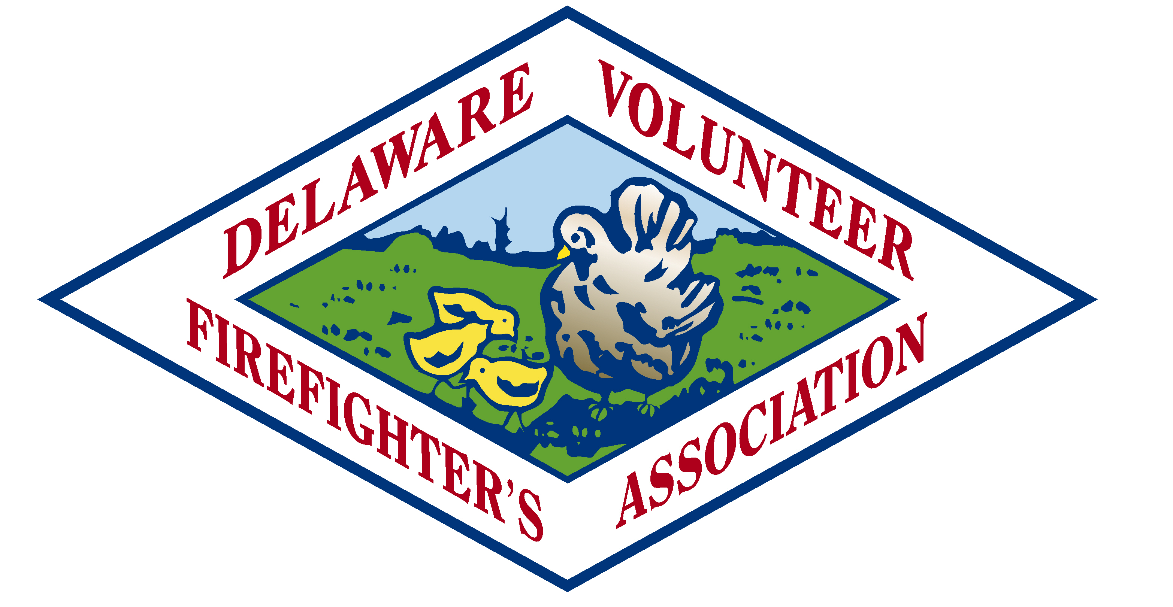

Official Address Phone Numbers

Delaware Volunteer Firefighter’s Association 302-734-9390 (Office)
P O Box 1849 302-734-9404 (Fax)
122- South Bradford St. 877-455-3832 (Toll Free)
Dover, DE 19903-1849 Website: www.dvfassn.com

County Presidents
Keith Bowman
New Castle
302-250-3204
Allan Post

Kent County
302) 423-2751
Ron O’Neal
Sussex County
302-249-3972 C
DVFA Chaplain
Pastor Bob Hudson
P.O. Box 1237
Millsboro, DE 19966
302-934-9874 H

TO:2017 DVFA SCHOLARSHIP APPLICANT
FROM: SCHOLARSHIP COMMITTEE
RE: APPLICATION PACKETS

Thank you for considering the Delaware Volunteer Firefighter’s Association Scholarship program. We have posted all of the necessary information to make your application to this program as simple as possible. Please remember that all information submitted to the Scholarship Committee must be typed and mailed directly to the address shown. DO NOT give any information to a DVFA firefighter or Ladies Auxiliary member for delivery to either the Fire School or to the Scholarship Committee. The Scholarship Committee will automatically reject information received in this manner.
Should you have specific questions, you may call either of the Co-Chairmen of the DVFA Scholarship Committee, Bob Powell at 302-539-4666, Daniel Carrier at 302-635-4224, or Rod O’Neal at 302-270-1596 THE DEADLINE FOR THIS YEAR’S SCHOLARSHIP APPLICATION IS THURSDAY, MARCH 31, 2017. Remember, all information (i.e. application, letters of recommendation, college and fire school transcripts, etc.) must be postmarked no later than March 31, 2017, in order to be considered for this year’s scholarship.
GOOD LUCK!!
Bob Powell, Chairman
Daniel Carrier, Co-Chair
Rod O’Neal, Co-Chairman
DVFA Scholarship Committee

